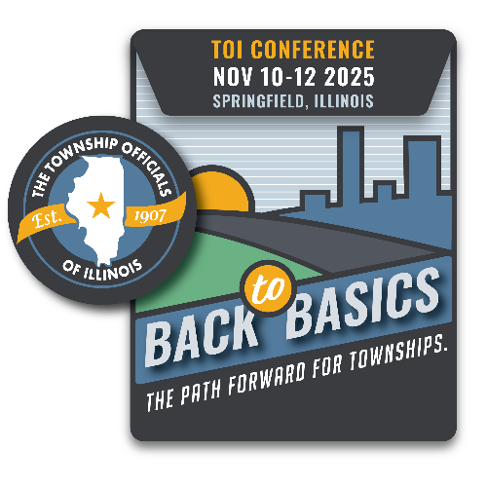**2025 Newly Elected Official Training**

**Virtual or In Person Events Registration**

**May 28 8:00 am – 3:00 pm**

In Person or via Zoom: Northfield Inn

Springfield, IL 62702

**June 17 8:00 am – 3:00 pm**

In Person or via Zoom:

Marriot Conference Center

1801 Naper Blvd.

Naperville, IL 60563

**Agenda**

8:00 AM Registration

9:00 AM Program Introduction

Pledge of Allegiance

Opening Comments, *Craig Paulek, TOI President*

Welcome, *Jerry B. Crabtree, TOI Executive Director*

9:30 AM TOIRMA The Importance of Township Safety

10:15 AM Budget and Levy

11:30 AM Lunch

12:15 PM Policies and Procedures for Townships

1:15 PM FOIA/OMA

2:45 PM Ask an Attorney

3:00 PM Adjourn

(program subject to change)

County Township

Address City State Zip

Names & Email of those who will attend (please print clearly):

Supervisor: Township Clerk: Highway Comm.: Assessor: Trustee: Trustee: Trustee: Trustee: Collector: Other/title:

***Registration is $25 per person/online and $50 per person for in person. Register an entire township for $100 (5 max).***

*Please make checks payable to the Township Officials of Illinois; mail to 3217 Northfield Drive., Springfield, IL 62702. Forms may also be emailed to [teresa@toi.org.](mailto:teresa@toi.org.%20) If you are paying by credit card, only Visa and MasterCard are accepted:

Name, as it appears on card: Credit Card Number Exp.: